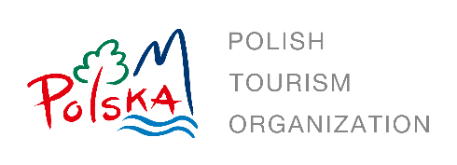
REQUEST FOR PROPOSALS

Contact: Polish National Tourist Office (PNTO), Chicago, USA
Date of Issue: 8 February 2024
Deadline: 15 February 2024

The Polish National Tourist Office (PNTO) in Chicago is looking for an experienced hotel distribution platform that will create a media plan and execute a marketing campaign that highlights Poland’s hotels and Polish hospitality. This campaign seeks not only to bolster Poland's positive image among North American travel advisors, but also to elevate awareness about Poland's unique accommodations. The goal of this initiative is to transform potential interest into tangible action, converting those who aspire to visit Poland into actual visitors.

Section 1: TARGET DATES FOR THIS RFP
The following schedule summarizes significant target events for the RFP process. The dates may be changed by PNTO at its sole discretion.
- RFP issue date: 8 February 2024
- RFP close date: 15 February 2024
- Notification of awarded company: 16 February 2024

Section 2: CAMPAIGN OVERVIEW

Campaign execution period: 3 months

Target group: North American travel advisors

Section 3: KPI
- Reach: Number or impressions
- Number of clicks (CTR)
- PAX production increase as compared to the same timeline in 2023

Section 4: BUDGET
- Total budget is 25,500 USD gross

Section 5: SCOPE OF WORK (SOW) FOR BID
You are asked to submit a proposal that includes the following information:
- Campaign overview
- Estimated impressions
- Estimated PAX production increase

Section 6: ENQUIRIES:
- Questions regarding requirements and scope of work will be received up to
14 February 2024 via email only at bartosz.szajda@pot.gov.pl and maciej.olchawa@pot.gov.pl.
- Questions submitted after 14 February 2024 will not be responded to.

No verbal inquiries or verbal requests for clarifications will be accepted.
Section 7: SUBMISSION REQUIREMENTS
Proposals should be emailed to bartosz.szajda@pot.gov.pl and maciej.olchawa@pot.gov.pl. Only the awarded company will be notified by email.

